Chemistry PhET Simulation

Goal: To investigate relationships between frequency, wavelength and energy of emitted photons of light.

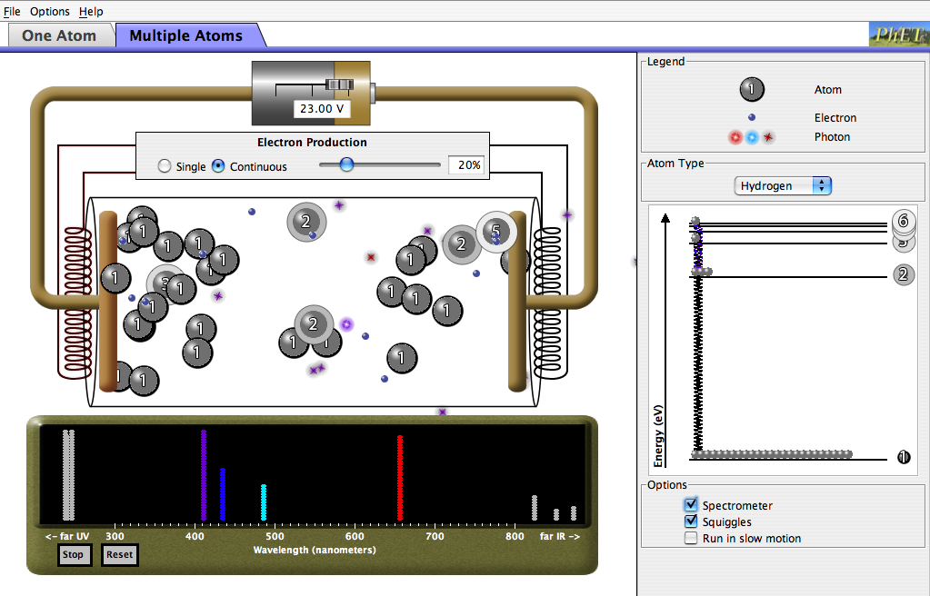
Open the PhET model, “Neon Lights and other Discharge Lamps”. Spend a few minutes familiarizing yourself with the discharge tubes model. Try clicking on different options, check all of the checkboxes, and get a general feel for how the model works. Investigate both the one atom and multiple atoms tabs.

Part 1: How is E/M Light Produced?
Directions: In the options (lower right on the model), check the spectrometer and squiggle settings. Notice the energy diagram on the right of the model, as well as the red arrow labeled “Energy at collision”.

- Paying particular attention to the energy diagram in the model, describe the process by which the emission of electromagnetic radiation (light) occurs.

- What evidence do you see which suggests that light is emitted in quantized amounts? Explain. [Ref. pp. 97-103 in your text.]

- Is it possible for a single electron to collide with the atom of hydrogen which results in more than one photon (particle) of light being emitted? Explain how. [Utilize the slow motion option for this!]

Part 2: E/M Properties
Directions: Click on the “Multiple Atoms” tab on the model. Make sure that the Spectrometer and Squiggle options are checked. For each of the available gases given in the drop down menu on the right side of the model, record the colors and intensities of light in the visible spectrum emitted by each element.

Hydrogen Emission Spectra | Mercury Emission Spectra
Sodium Emission Spectra | Neon Emission Spectra

- Based upon your observations using this model, which colors of visible light are highest in energy? Justify your response.

- Cite observations from the model to explain relationships between the following:

(I) Frequency and energy

(II) Wavelength and energy

(III) Frequency and wavelength

Part 3: Application
In trying to observe tiny tiny things in the world around us, we often use an optical microscope, which relies upon emitted photons of light to resolve the tiny object that we are interested in observing.
- What is the practical limit of a tiny object which we could use visible light (assume a wavelength of 5.25 x 10⁻⁷m) to resolve under ideal conditions in air? [Reference the Wikipedia section on the Limitations of Optical Microscopes.] Show your work and label your answer with the proper units.

- Which of the following objects would be visible within the limits of an optical microscope? Provide an approximate size, and circle the visible objects.
Size (m)
  - Lymphocyte
  - Cell nucleus
  - Bacterium
  - H1N1 Virus
  - Buckyball (C₆₀)
  - Glucose molecule (C₆H₁₂O₆⁾
  - Hydrogen molecule (H₂)

[Critical Thinking] Study the image of the modern microscope shown in the Limitations section of the Optical Microscope entry on Wikipedia.
- Why is a mercury bulb necessary for fluorescence microscopy?

- Would any of the other gases you observed in the model work? Explain why/why not.

